Speed:

I am setting the starting speed to 0 and increasing it exponentially till <49 mph.
This is how I solve the starting jerk issue.

To avoid jerk, I am call increase_speed and slow_down functions which increase/decrease speed by 0.5 at a time.
This way I keep the AccT between +4 to -4 m/s^2

Driving model:

I am implementing a simple model to make sure the car drives smoothly, avoiding any collisions or jerks.

Please see below diagram.
This is the Top level representation of my alogrithm.

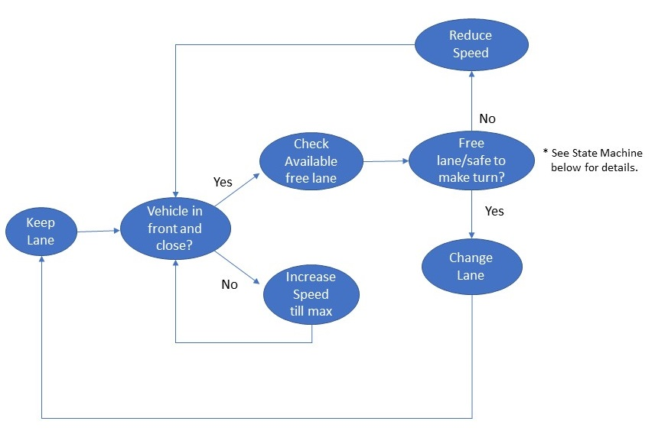

The state machine for lane change is as below:

